Form No.: TSU-RSP-SF-44 | Revision No.: 00 | Effectivity Date: October 6, 2023 | Page 1 of 1
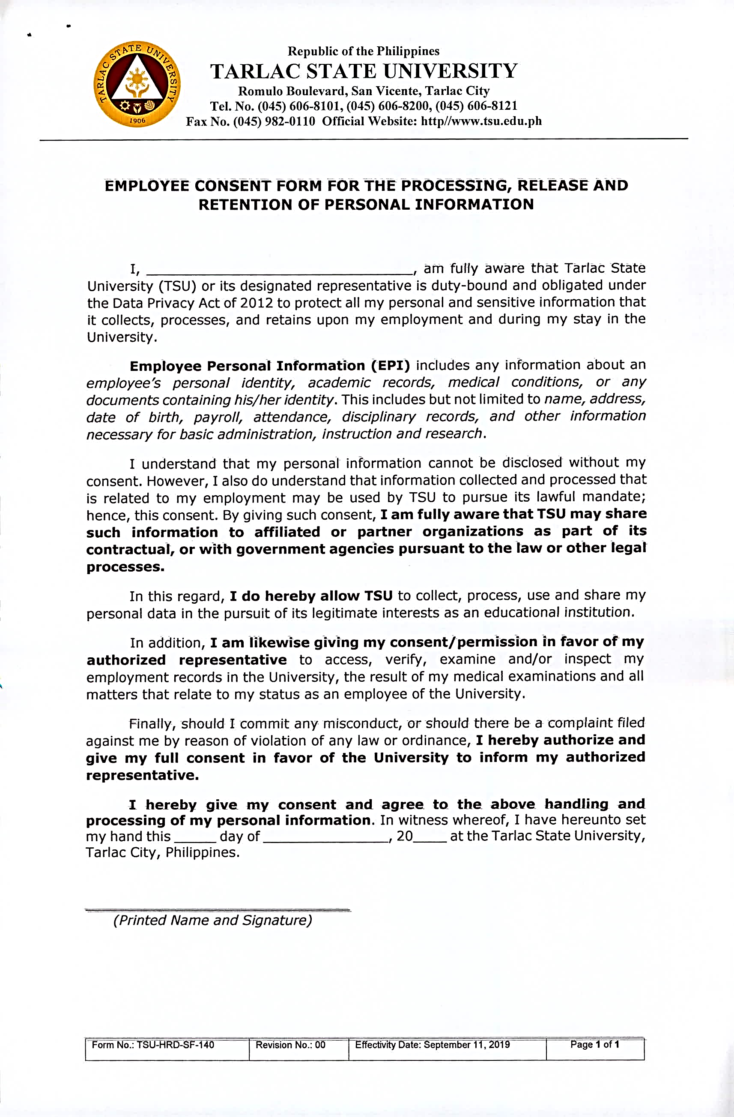

TARLAC STATE UNIVERSITY
OFFICE OF HUMAN RESOURCE DEVELOPMENT & MANAGEMENT
RECRUITMENT, SELECTION AND PROMOTION UNIT

